***A Report on***

**SMART HOME ASSISTANT – TELEGRAM BOT**

**INTRODUCTION**

A smart home refers to a convenient home setup where appliances and devices can be automatically controlled remotely from anywhere with an internet connection using a mobile or other networked device. Devices in a smart home are interconnected through the internet, allowing the user to control functions such as security access to the home, temperature, lighting, and a home theater remotely. A smart home’s devices are connected with each other and can be accessed through one central point—a smartphone, tablet, laptop, or game console. Door locks, televisions, thermostats, home monitors, cameras, lights, and even appliances such as the refrigerator can be controlled through one home automation system. The system is installed on a mobile or other networked device, and the user can create time schedules for certain changes to take effect.

**SYSTEM DESCRIPTION**

In the present trend and technologies smart homes has become a buzzword. making the homes smart using the emerging technologies like the Internet of things and Artificial intelligence has become more popular. The smart home control a range of connected devices in your home from your smartphone. From lights to alarms, the idea is that as long as both your home and your phone are connected to the internet, you have control over them.

Connecting the devices and appliances in the home so that they can communicate is a lot easier than you think. Smart home assistant which allows the user to control the appliances in the home by simply chatting with the telegram bot. The bot also helps you in monitoring different environment parameters of your home with the help of the sensors.

In this project, We can get the illumination levels, temperature and humidity parameters and control the appliances like lights and fans by sending the text messages from the telegram app.

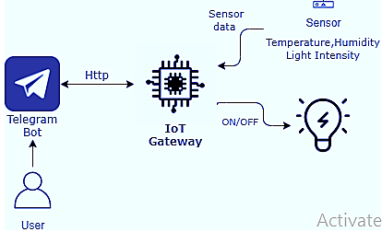

***1. ESP-WROOM-32 Module***

The development board equips the ESP-WROOM-32 module containing Tensilica Xtensa® Dual-Core 32-bit LX6 microprocessor. This processor is similar to the ESP8266 but has two CPU cores (can be individually controlled), operates at 80 to 240 MHz adjustable clock frequency and performs at up to 600 DMIPS (Dhrystone Million Instructions Per Second). There’s also 448 KB of ROM, 520 KB of SRAM and 4MB of Flash memory (for program and data storage) just enough to cope with the large strings that make up web pages, JSON/XML data, and everything we throw at IoT devices nowadays.

The ESP32 Integrates 802.11b/g/n HT40 Wi-Fi transceiver, so it can not only connect to a WiFi network and interact with the Internet, but it can also set up a network of its own, allowing other devices to connect directly to it. The ESP32 supports [WiFi Direct](https://en.wikipedia.org/wiki/Wi-Fi_Direct) as well, which is a good option for peer-to-peer connection without the need of an access point. The WiFi Direct is easier to setup and the data transfer speeds are much better than Bluetooth.

The chip also has dual mode Bluetooth capabilities, meaning it supports both Bluetooth 4.0 (BLE/Bluetooth Smart) and Bluetooth Classic (BT), making it even more versatile.

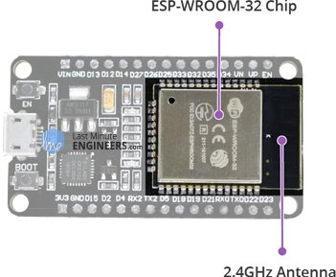

***2. DHT 11 Sensor***

The DHT sensors are made of two parts, a capacitive humidity sensor and a thermistor. There is also a very basic chip inside that does some analog to digital conversion and spits out a digital signal with the temperature and humidity. The digital signal is fairly easy to read using any microcontroller.

* Ultra low cost
* 3 to 5V power and I/O
* 2.5mA max current use during conversion (while requesting data)
* Good for 20-80% humidity readings with 5% accuracy
* Good for 0-50°C temperature readings ±2°C accuracy
* No more than 1 Hz sampling rate (once every second)
* Body size 15.5mm x 12mm x 5.5mm
* 4 pins with 0.1" spacing

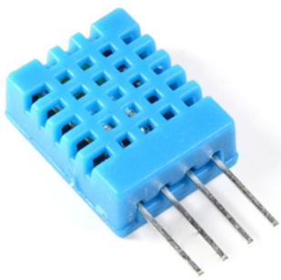

***3. Light dependent resistor (LDR)***

The light dependent resistor (LDR) is designed with the highest resistance semiconductor metal. If the light falls on the device, then the photons produce the electron energy and it makes them bound into the conductive band. Hence it conducts electricity. The LDR circuit is also known as photo resistors. Here we will see the symbol of the LDR.

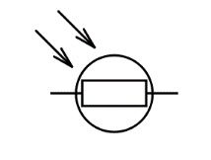

***Light Dependent Resistor***

The working principle of the LDR is based on the photoconductivity and it is an optical phenomenon. The material conductivity is increased when the light is riveted by the material. If the light falls (photons) on the device, the electrons which are in the valence band of the semiconductor material are moved to the conduction band. These photons in the occurrence, the light will have the energy greater than the bandgap of the semiconductor material to move the electrons to valence band to the conduction band.

Therefore, therefore the light will strike the sufficient energy on the device and there is more electrons are eager to the conduct, therefore, the result will be in a large number of charge carriers. Hence the result of this process, when the circuit is closed more current is flowing through the device and the resistance of the device is decreased.

**CONCLUSION**

Smart home assistant which allows the user to control the appliances in the home by simply chatting with the telegram bot is done. The bot helps in monitoring different environment parameters of your home with the help of the sensors. In this system, we can get the illumination levels, temperature and humidity parameters and control the appliances like lights and fans by sending the text messages from the telegram app.